**PRUEBAS CASO 7100**

SE REALIZAN PRUEBAS DE ESTE REQUERIMIENTO A UNQUE ESTE NO APLIQUE PARA GASES DEL CARIBE POR EL MOMENTO, SE TOMA COMO REFERENCIA EL MES DE MAYO PARA REALIZAR DICHA PRUEBA, EL RESULTADO DEBE SER IGUAL AL OBTENIDO EN SU MOMENTO.

NO ES POSIBLE COMPARAR, PARA ESTE CASO, LAS ORDENES INTERNAS EN LOS CLASIFICADORES RESPECTIVOS PARA EL COMPROBANTE DE INGRESOS DE VENTA ORDEN, YA QUE LA CONSULTA QUE SE TENIA EN SU MOMENTO NO MOSTRABA LA ORDEN INTERNA Y NO PODEMOS DE REGISTRO CONTABLES OBTENER DIVHA ORDEN, REALIZAMOS CONSULTAS A NIVEL DE COMPROBANTE, CUENTA Y SIGNO PARA QUE SE COMPARE LOS RUBROS Y SE NOTE QUE NO SE PRESENTA DIFERENCIA.

REVERSAMOS EL COMPROBANTE DE VENTA ORDEN

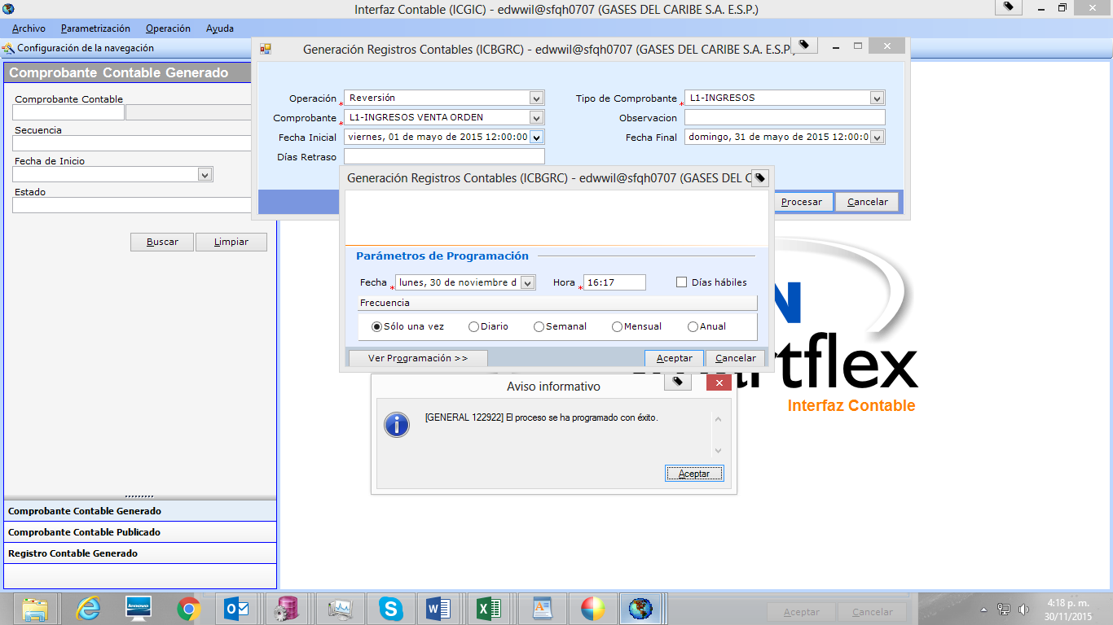

GENERAMOS REGISTROS CONTABLES PARA EL COMPROBANTE VENTA ORDEN

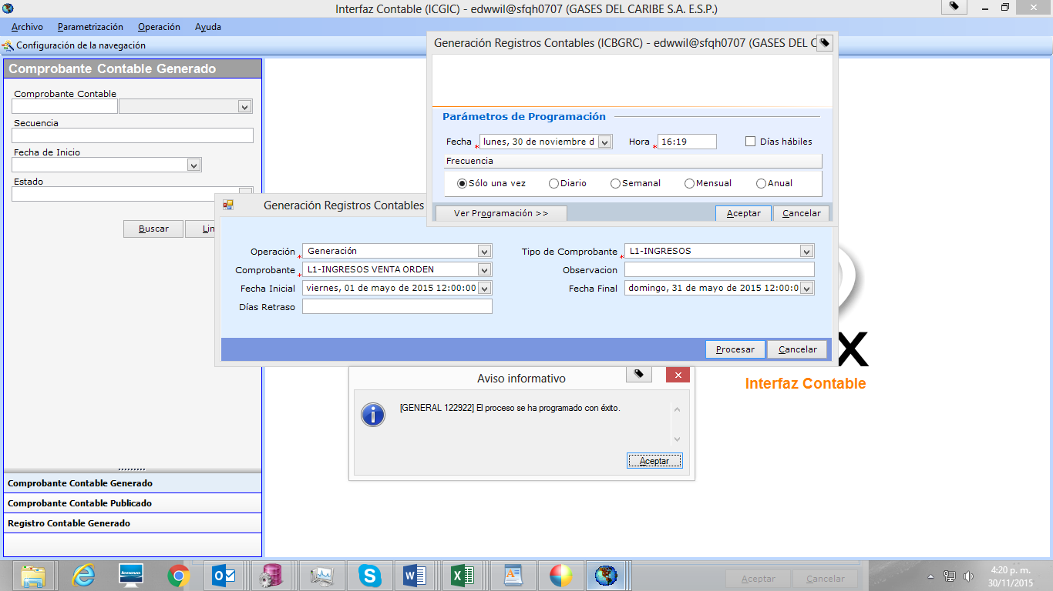

VALIDAMOS QUE EL PARAMETRO 'LDC_ORDEN_INTERNA_PROD_GENE' TENGA EL NIT DE GASES DE CARIBE PARA QUE EJECUTE EL PROCESO, ESTE ES LA VALIDACION QUE TIENE EN CUENTA EL PAQUETE PARA REALIZAR DICHO PROCESO.

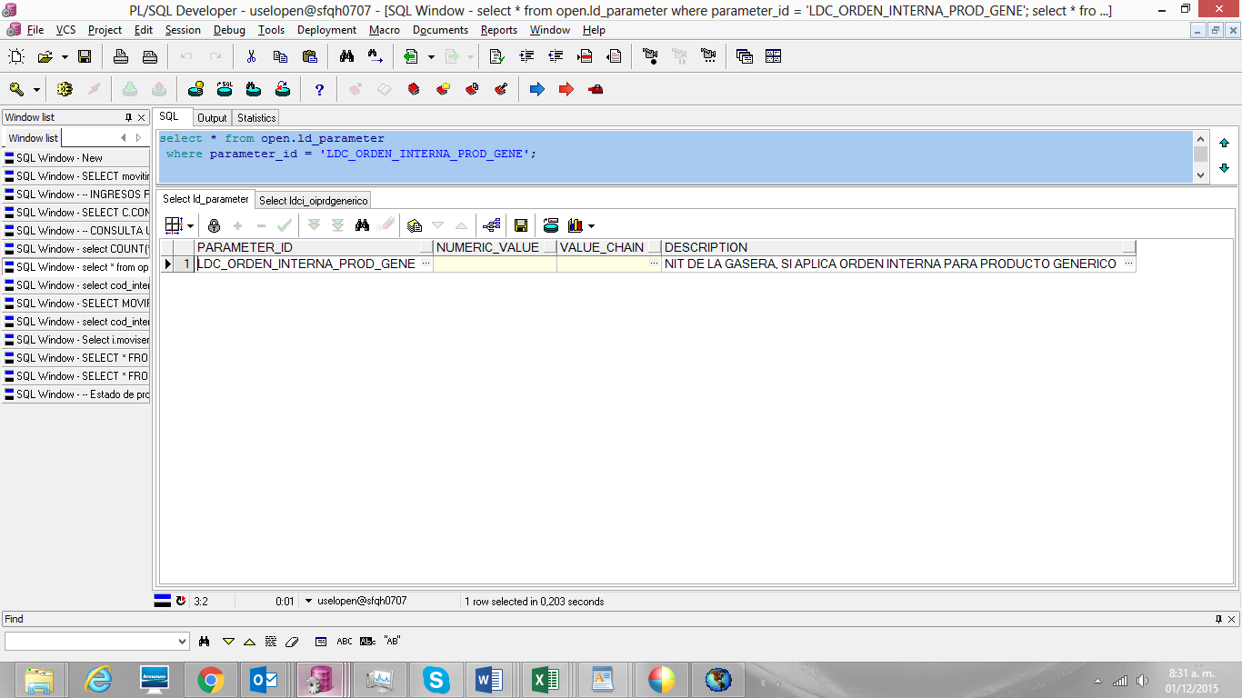

GENERAMOS LA NUEVA TRAMA

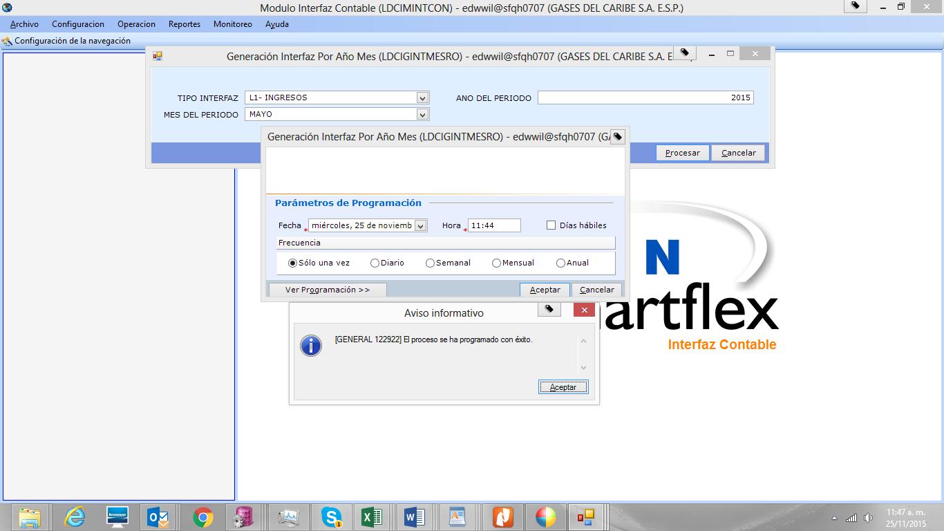

VALIDAMOS LA TRAMA GENERADA EN SU MOMENTO Y LA NUEVA GENERADA CON EL NUEVO PROCESO.

SE APRECIA QUE NO HAY CAMBIOS EN LA INTERFAZ, LA DIFERENCIA PRESENTADA DE LOS 7 PESOS, SE DEBE A UN CAMBIO EN LA CONFIGURACION EN LA INTERFAZ Y ESTA BIEN, PERO EL RESULTADO EN EL TOTAL AL FINAL ES EL MISMO.

|  |  |  |  |  |  |  |  |
| --- | --- | --- | --- | --- | --- | --- | --- |
| **COMPROBANTE ACTUAL 5110** | | |  | **COMPROBANTE ORIGINAL 4686** | | |  |
| **CUENTA** | **C** | **D** |  | **CUENTA** | **C** | **D** | **DIF.** |
| **1** |  |  |  | **1** |  |  |  |
| 1406060101 | - 540 |  |  | 1406060101 | 540 |  | - |
| 1407170101 |  | 27.916.691 |  | 1407170101 |  | 27.916.691 | - |
| 1407900101 | - 121.618.848 | 150.714.151 |  | 1407900101 | 121.618.848 | 150.714.151 | - |
| 1407901101 | - 41.836.682 | 621.333.012 |  | 1407901101 | 41.836.682 | 621.333.012 | - |
| 1407904101 | - 239.381.344 | 1.078.452 |  | 1407904101 | 239.381.344 | 1.078.452 | - |
| 1407907101 |  | 420.266.036 |  | 1407907101 |  | 420.266.036 | - |
| 1407909501 | - 2.691.653 | 2.403.411 |  | 1407909501 | 2.691.653 | 2.403.411 | - |
| 1408050101 | - 141.220.995 | 1.107.100.370 |  | 1408050101 | 141.220.995 | 1.107.100.370 | 0 |
| 1408051101 | - 7.685.837.432 | 56.887.202.779 |  | 1408051101 | 7.685.837.432 | 56.887.202.779 | - |
| 1470031101 | - 4.169.742 | 1.517.493.405 |  | 1470031101 | 4.169.742 | 1.517.493.405 | - |
| 1470033101 | - 55 | 26.503 |  | 1470033101 | 55 | 26.503 | - |
| 1470034101 | - 183.002 | 332.784.800 |  | 1470034101 | 183.002 | 332.784.800 | - |
| 1470035101 | - 891.697 | 119.546 |  | 1470035101 | 891.697 | 119.546 | - |
| 1470037101 | - 6.940.760 | 1.471.147.833 |  | 1470037101 | 6.940.760 | 1.471.147.833 | - |
| 1470038101 | - 7.545.891 | 2.389.408.190 |  | 1470038101 | 7.545.891 | 2.389.408.190 | - |
| 1470039101 | - 54.451 |  |  | 1470039101 | 54.451 |  | - |
| 2425100100 | - 420.326.716 | 239.306.308 |  | 2425100100 | 420.326.716 | 239.306.308 | - |
|  |  |  |  | 2425901200 |  | 7 | - 7 |
| 2425902100 | - 102.428.933 | 1.358.078.797 |  | 2425902100 | 102.428.933 | 1.358.078.790 | 7 |
| 2430151100 | - 18.238.929 | 5.301.178.594 |  | 2430151100 | 18.238.929 | 5.301.178.594 | - |
| 2430152100 | - 154.888.898 | 1.465.700 |  | 2430152100 | 154.888.898 | 1.465.700 | - 0 |
| 2430152300 | - 310.182 | 1.987.311 |  | 2430152300 | 310.182 | 1.987.311 | - |
| 2430152400 | - 262.227.086 | 2.100.481 |  | 2430152400 | 262.227.086 | 2.100.481 | - 0 |
| 2430152500 | - 211.140.246 | 31.229.643 |  | 2430152500 | 211.140.246 | 31.229.643 | - |
| 2445020000 | - 91.279.747 | 419.688 |  | 2445020000 | 91.279.747 | 419.688 | - |
| 2450010300 |  | 11.561 |  | 2450010300 |  | 11.561 | - |
| 4325260400 | - 230.168.671 | 5.579.421 |  | 4325260400 | 230.168.671 | 5.579.421 | - |
| 4325260500 | - 858.850.719 | 4.780.428 |  | 4325260500 | 858.850.719 | 4.780.428 | - 0 |
| 4325260600 | - 792.000 | 198.000 |  | 4325260600 | 792.000 | 198.000 | - |
| 4325270100 | - 815.308.686 | 26.905.273 |  | 4325270100 | 815.308.686 | 26.905.273 | - 0 |
| 4325270200 | - 55.345.849.750 | 207.442.026 |  | 4325270200 | 55.345.849.750 | 207.442.026 | - 0 |
| 4390040100 | - 27.916.691 |  |  | 4390040100 | 27.916.691 |  | - |
| 4390900102 | - 260.309.681 | 11.481.566 |  | 4390900102 | 260.309.681 | 11.481.566 | - 0 |
| 4390900110 | - 352.315.671 | 2.114.816 |  | 4390900110 | 352.315.671 | 2.114.816 | 0 |
| 4390900301 | - 1.516.839.589 |  |  | 4390900301 | 1.516.839.589 |  | - 0 |
| 4390900303 | - 56.369 | 1.481.639 |  | 4390900303 | 56.369 | 1.481.639 | - |
| 4390900305 | - 119.546 |  |  | 4390900305 | 119.546 |  | - |
| 4390900307 | - 2.421.110.431 | 795.074 |  | 4390900307 | 2.421.110.431 | 795.074 | 0 |
| 4390900308 | - 1.465.787.526 | 733.213 |  | 4390900308 | 1.465.787.526 | 733.213 | 0 |
| 4390900315 | - 5.129.006 | 1.787 |  | 4390900315 | 5.129.006 | 1.787 | 0 |
| 4395900103 | - 15.524.013 |  |  | 4395900103 | 15.524.013 |  | - |
| 4805130101 | - 50.009.273 | 51.373 |  | 4805130101 | 50.009.273 | 51.373 | - 0 |
| 4805130201 | - 301.966.820 | 22.817.795 |  | 4805130201 | 301.966.820 | 22.817.795 | 0 |
| 4810470100 | - 100.000 | 1.028.667.081 |  | 4810470100 | 100.000 | 1.028.667.081 | - |
| 5101300200 |  | 3.545.517 |  | 5101300200 |  | 3.545.517 | - |
| **6** |  |  |  | 6 |  |  |  |
| 1407902101 | - 189.916.672 | 9.082.011.679 |  | 1407902101 | 189.916.672 | 9.082.011.679 | - |
| 1407906101 | - 156.907 | 50.172.092 |  | 1407906101 | 156.907 | 50.172.092 | 0 |
| 2425902100 | - 86.685.283 | 85.025.158 |  | 2425902100 | 86.685.283 | 85.025.158 | - |
| 2425909100 | - 9.045.498.488 | 105.048.421 |  | 2425909100 | 9.045.498.488 | 105.048.421 | - 0 |
| **29** |  |  |  | 29 |  |  |  |
| 1407900101 | - 37.370.948 | 1.371.226.460 |  | 1407900101 | 37.370.948 | 1.371.226.460 | - |
| 1407901101 | - 3.074.241 | 123.824.681 |  | 1407901101 | 3.074.241 | 123.824.681 | - |
| 1408050101 | - 29.373.616 | 806.119.243 |  | 1408050101 | 29.373.616 | 806.119.243 | - |
| 1470900100 |  | 36.158.561 |  | 1470900100 |  | 36.158.561 | - |
| 2445020000 | - 59.766.503 | 25.966 |  | 2445020000 | 59.766.503 | 25.966 | - |
| 2915030000 | - 2.241.403.881 | 6.124.791 |  | 2915030000 | 2.241.403.881 | 6.124.791 | 0 |
| 4395900103 |  | 27.509.487 |  | 4395900103 |  | 27.509.487 | - |
| **50** |  |  |  | 50 |  |  |  |
| 1406060101 | - 98.418 |  |  | 1406060101 | 98.418 |  | - |
| 1407900101 | - 345.405.532 |  |  | 1407900101 | 345.405.532 |  | - |
| 1407901101 | - 71.300.861 |  |  | 1407901101 | 71.300.861 |  | - |
| 1407902101 | - 87.879.849 |  |  | 1407902101 | 87.879.849 |  | - |
| 1407906101 | - 110.411 |  |  | 1407906101 | 110.411 |  | - |
| 1408050101 | - 70.189.544 |  |  | 1408050101 | 70.189.544 |  | - |
| 1408051101 | - 127.172.058 | 7.898.429 |  | 1408051101 | 127.172.058 | 7.898.429 | - |
| 1470031101 | - 5.778.261 |  |  | 1470031101 | 5.778.261 |  | - |
| 1470034101 | - 5.008 |  |  | 1470034101 | 5.008 |  | - |
| 1470037101 | - 161.099.260 | 1 |  | 1470037101 | 161.099.260 | 1 | - |
| 1470038101 | - 38.634.850 |  |  | 1470038101 | 38.634.850 |  | - |
| 1480230100 | - 7.898.430 | 816.847.099 |  | 1480230100 | 7.898.430 | 816.847.099 | - |
| 1480900200 |  | 90.826.953 |  | 1480900200 |  | 90.826.953 | - |
| **51** |  |  |  | 51 |  |  |  |
| 1407900101 | - 6.383.487 | 7.768 |  | 1407900101 | 6.383.487 | 7.768 | - |
| 1407901101 | - 413.165 |  |  | 1407901101 | 413.165 |  | - |
| 1408050101 |  | 855 |  | 1408050101 |  | 855 | - |
| 1408051101 | - 29.410.302 | 153.309 |  | 1408051101 | 29.410.302 | 153.309 | - |
| 1470034101 | - 35.380 |  |  | 1470034101 | 35.380 |  | - |
| 1470037101 | - 114.143.951 |  |  | 1470037101 | 114.143.951 |  | - |
| 1470038101 | - 17.936.674 |  |  | 1470038101 | 17.936.674 |  | - |
| 1480230100 | - 161.932 | 168.287.579 |  | 1480230100 | 161.932 | 168.287.579 | - |
| 1480900200 |  | 35.380 |  | 1480900200 |  | 35.380 | - |
| **59** |  |  |  | 59 |  |  |  |
| 1406060101 |  | 64.277 |  | 1406060101 |  | 64.277 | - |
| 1407900101 | - 342.234 | 17 |  | 1407900101 | 342.234 | 17 | - |
| 1407901101 |  | 23.447.794 |  | 1407901101 |  | 23.447.794 | - |
| 1407902101 |  | 528.171 |  | 1407902101 |  | 528.171 | - |
| 1407906101 |  | 4.974 |  | 1407906101 |  | 4.974 | - |
| 1408050101 | - 348.292 | 27.374.476 |  | 1408050101 | 348.292 | 27.374.476 | - |
| 1408051101 | - 3.557.916 | 50.125.025 |  | 1408051101 | 3.557.916 | 50.125.025 | - |
| 1470031101 |  | 134.273 |  | 1470031101 |  | 134.273 | - |
| 1470037101 |  | 53.748.831 |  | 1470037101 |  | 53.748.831 | - |
| 1470038101 |  | 5.630.572 |  | 1470038101 |  | 5.630.572 | - |
| 1470039101 |  | 85.780.302 |  | 1470039101 |  | 85.780.302 | - |
| 1470900100 | - 25.320.268 |  |  | 1470900100 | 25.320.268 |  | - |
| 2425902100 |  | 650.139 |  | 2425902100 |  | 650.139 | - |
| 4810081100 | - 221.518.444 | 3.598.303 |  | 4810081100 | 221.518.444 | 3.598.303 | - |
|  | - 86.209.759.337 | 86.209.759.337 |  |  | 86.209.759.337 | 86.209.759.337 |  |